DEEP ROOT /UNIVERSAL EGG RELEASE

Release Notes for ROOT039 7” vinyl

• DUB CONFERENCE SERIES PART 6



Abassi All stars in collaboration with Deep Root present the sixth release in
the DUB CONFERENCE 7 inch release series which will feature collaborations
between Abassi All Stars and many of the serious dub producers of the globe. This
release features the sounds of Ital Noiz from Roma, Italy alongside Abassi. The theme of the
series is to take a co-written tune and have it mixed by each production team,
presenting the results as a 7 inch release. .

Release Date 28th June 2010

The 7” release has EXCLUSIVE mixes that will not be featured on any other
release with an Abassi dub cut on the A side and an Ital Noiz cut on the
flipside.

This 7” release is a limited edition release as always on Deep Root. These tunes
already have UK and German radio air play and sound system play on Iration
Steppers, Vibronics, King Shiloh, Jah Tubby World System and perch’s Abassi Hi
Power systems

This release is on SILVER vinyl.

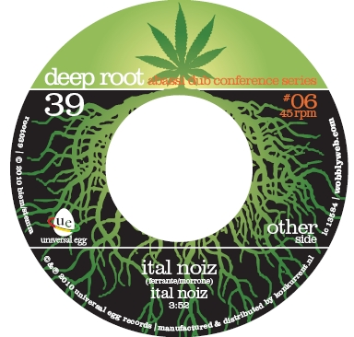

Root039 Tracklist

Side A
Ital Dub by Abassi All Stars

Side B
Ital Noiz by Ital Noiz

orders
perch@wobblyweb.com

More info on this release
http://www.wobblyweb.com/ue/abassi-all-stars-meets-ital-noiz.html

More info on Abassi All Stars
http://www.wobblyweb.com/ue/abassiallstars.html

